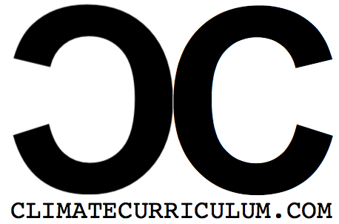
Climate Curriculum
Lesson Plan Feedback Tool

Please use the following document to provide meaningful feedback for the lessons on Climate Change. Please try to be direct and specific noting any suggestions or changes to the lesson, generalized statements are more difficult to incorporate. Also, if you have an idea of lesson plan extensions or additional lessons for the Units, please be sure to include this information as well.

Lesson Planning
1. Are the essential questions appropriate for the lesson? (If not, suggestions?)

2. Does the lesson align with the Science Frameworks suggested? (If not, suggestions?)

3. Are the content, practice and language objectives appropriate? (If not, suggestions?)

4. Would additional vocabulary words be helpful to promote deeper student understanding? (Suggestions?)

Materials
1. Are the materials for the lesson sufficient? Would additional material help the lesson? (Suggestions?)

Background Knowledge
1. Does the background knowledge of the student need to be addressed prior to delivering the lesson? (Suggestions?)

2. Does the background knowledge of the teacher need to be addressed prior to delivering the lesson? (Suggestions?)

Lesson Structure
Is the structure of the lesson sufficient? Are there any suggestions or concerns with the following?...

Lesson Launch

Background Instruction

Activity

Discussion/Debrief

Formative Assessment

Additional Comments/Concerns
Please feel free to elaborate on any suggestions/ideas/feedback on the lesson.

